Lesson 2: How does being distracted affect whether or not you will avoid a collision?

Previous Lesson | We determined that the number of injuries and vehicle collisions has increased in recent years and developed models to try to explain how distracted driving and other vehicle factors and features might contribute to those trends. We asked questions about these potential causes of these trends, and developed ideas for investigation.
This Lesson  Investigation  2 days   | 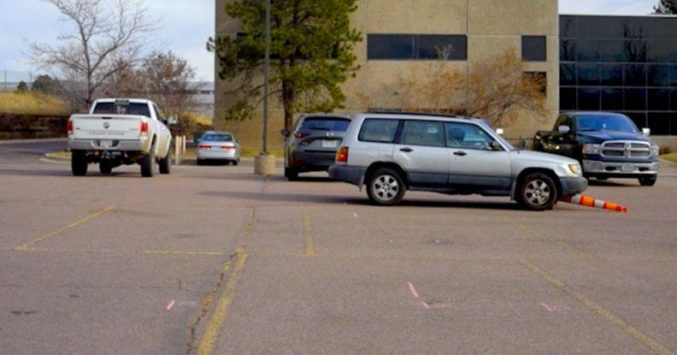 | We analyze videos of two drivers encountering a sudden obstacle, one who is not distracted, and one who is distracted. We make plots for each driver to show how being distracted affects the motion of the vehicle over time, and thus the outcome of a potential vehicle collision.
Next Lesson | We will use mathematical models to generate data about how speed affects stopping distance based on average reaction times for distracted vs. non-distracted drivers. We will use what we have figured out from video data and mathematical modeling to identify design features that can decrease stopping distances to prevent collisions in the event of a sudden obstacle.

BUILDING TOWARD NGSS  HS-ETS1-3, HS-PS2-2, HS-PS2-3, HS-PS2-1   | What students will do  2.A Analyze video of two drivers encountering a sudden obstacle by graphing change in distance over time, in order to describe and predict how being distracted can affect the risk of a potential vehicle collision. (SEP: 4.1; CCC: 7.2; DCI:ETS1.A.2)  What students will figure out  - We can plot the distance that a vehicle travels over time to learn more about how it is moving, including its speed.  - Distracted driving lengthens reaction time, which means that you will have less distance over which to stop before the obstacle.

Lesson 2 • Learning Plan Snapshot
Part | Duration | Summary | Slide | Materials
1 | 3 min | NAVIGATE  Motivate watching videos of distracted and non-distracted drivers with a quick initial ideas discussion about how being distracted will affect one’s ability to avoid a collision. | A
2 | 15 min | ANALYZE VIDEO OF A CAR STOPPING (CLIP #1)  Watch the videos and elicit noticings about differences. Create a position-line for the distracted driver. Elicit ideas about how to calculate distance. | B-D | https://www.youtube.com/watch?v=Z11esq-Zs2E&list=PLSLDxqPb5NQmc9aOPrh0SjG_BRiZsVdWA&index=4, https://www.youtube.com/watch?v=D2-2L_e3bLU&list=PLSLDxqPb5NQmc9aOPrh0SjG_BRiZsVdWA&index=5, one roll receipt paper, chart markers (at least three colors), meter stick
3 | 10 min | ADD DISTANCES TO POSITION LINE FOR CLIP #1  Calculate ΔX and add to the position-line. | E | Creating Position Lines, meter stick, chart markers (at least three colors)
4 | 15 min | ANALYZE THE DISTRACTED DRIVER (CLIP #2)  Make a prediction about a distracted driver. Compare predictions to the distracted driver. | F-H | toy car, one roll receipt paper
5 | 2 min | NAVIGATE AND ASSIGN HOME LEARNING  Motivate analysis of timing by using a manipulative, and assigning Home Learning. |  | Distracted Driving Research

End of day 1
6 | 3 min | NAVIGATE: REACTION TIME  Focus on the relationship between distraction and reaction time. Articulate our motivation to analyze timing
7 | 5 min | CREATE A TIMELINE OF CLIP #1 TOGETHER  Create a timeline of the non-distracted driver using the timecode in the video. | M | one roll receipt paper
8 | 20 min | CREATE A POSITION V. TIME GRAPH  As a class, re-orient our position line and our timeline so that they represent axes of a graph. Graph the important points for each video on this plot. | N-T | paper with three hole punch, graph paper with three hole punch, one roll receipt paper
9 | 15 min | GRAPH THE DISTRACTED SCENARIO IN PAIRS  Graph the collision if the driver was distracted in pairs. Debrief the graphing. | U-V | graph paper with three hole punch
10 | 2 min | NAVIGATE WITH AN EXIT TICKET  Administer an exit ticket. | W | paper for exit ticket

End of day 2

Lesson 2 • Materials List
 | per student | per group | per class
Lesson materials | - Creating Position Lines  - Distracted Driving Research  - paper with three hole punch  - graph paper with three hole punch  - paper for exit ticket |  | - https://www.youtube.com/watch?v=Z11esq-Zs2E&list=PLSLDxqPb5NQmc9aOPrh0SjG_BRiZsVdWA&index=4  - https://www.youtube.com/watch?v=D2-2L_e3bLU&list=PLSLDxqPb5NQmc9aOPrh0SjG_BRiZsVdWA&index=5  - one roll receipt paper  - chart markers (at least three colors)  - meter stick  - toy car

Materials preparation (45 minutes)

Review teacher guide, slides, and teacher references or keys (if applicable).

Make copies of handouts and ensure sufficient copies of student references, readings, and procedures are available.

Put three-hole-punches in all the images and handouts so they can be added to students’ notebooks.

Make sure the Distracted Driving Consensus Model is visible near the front of the room.

Prepare chart paper for posters.

Lesson 2 • Where We Are Going and NOT Going

This lesson is focused on some of the basic kinematic conventions and high school level computational thinking that students will need in future lessons in order to figure out how force, momentum and time are related in later lessons. Lessons 2 and 3 of this unit are the only lessons in the course that will focus on kinematics. Kinematics are not emphasized in the NGSS, which is why much of the physics in this lesson are not well aligned to high school Physical Science DCIs. Instead, the major standards-aligned ideas in this lesson are concerned with engineering, and identifying a major challenge with ramifications in communities, an important element of the disciplinary core idea ETS1.A.

This lesson and the next are designed to coherently build ideas related to the following disciplinary core ideas:
- ETS1.A.1: Defining and Delimiting Engineering Problems. Humanity faces major global challenges today, such as the need for supplies of clean water and food or for energy sources that minimize pollution, which can be addressed through engineering. These global challenges also may have manifestations in local communities. (HS-ETS1-1)
- ETS1.A.1: Defining and Delimiting Engineering Problems. Criteria and constraints also include satisfying any requirements set by society, such as taking issues of risk mitigation into account, and they should be quantified to the extent possible and stated in such a way that one can tell if a given design meets them. (HS-ETS1-1, secondary to HS-PS2-3)

Students will identify a major challenge - that distracted driving is dangerous, and consider how the risks associated with driving might be mitigated. In the next lesson, they will learn about a set of design solutions aimed at preventing distracted driving, and consider the constraints on these solutions set by society.

Students will explore the differences between position vs. time graphs for distracted and not distracted drivers. This lesson is focused on how being distracted affects the possibility of getting into a collision. In the next lesson, students will consider how the speed of a vehicle affects the possibility of getting into a collision using many of the same algebraic techniques. In Lessons 4-5, students will begin to apply their ideas about speed, distance, and time to think about the forces in a collision.

Students will co-construct definitions for the following vocabulary during this lesson: reaction time, reaction distance, braking distance. Be prepared for them to add these phrases to their personal glossaries. Do not ask students to define or keep track of any words until after your class has developed a shared understanding of their meaning.

LEARNING PLAN for LESSON 2
1 · NAVIGATE | 3 min
MATERIALS: None
Motivate watching videos of distracted and non-distracted drivers. Say, We wanted to investigate the impact of distracted driving on a vehicle collision. We had some ideas about how drivers might behave differently when they are focused and undistracted to reduce the chance of getting in a collision in the first place. Direct students’ attention to the class consensus model to illustrate this. Then present slide A with the prompt below and elicit 1-2 initial ideas.  Suggested prompt Sample student response  What does it mean to be distracted? Texting or being under the influence of a substance  Are all distractions as dangerous as texting or drinking? What are some other, maybe more common distractions? Talking to a friend Eating a snack Fixing makeup in a mirror Choosing a new song on your phone  It sounds like everyone is distracted when they are driving sometimes, even if it is just for a moment. How could being distracted affect whether or not you will avoid a collision? You will brake faster.  Say, I have video of a car braking when the driver is distracted, and when the driver is not distracted. Let’s take a look and see if we can break it down to test out our ideas about how being distracted affects whether or not you will avoid a collision. | ✱ ATTENDING TO EQUITY  Universal Design for Learning: The goal at this moment is to support engagement by allowing students to draw connections to everyday distractions in their own lives. Not every distracted driver is breaking the law. Use the second question in the table to push students to think beyond texting and drinking when it comes to distracted driving, and highlight the idea that everyone is distracted sometimes when they are driving.

2 · ANALYZE VIDEO OF A CAR STOPPING (CLIP #1) | 15 min
MATERIALS: https://www.youtube.com/watch?v=Z11esq-Zs2E&list=PLSLDxqPb5NQmc9aOPrh0SjG_BRiZsVdWA&index=4, https://www.youtube.com/watch?v=D2-2L_e3bLU&list=PLSLDxqPb5NQmc9aOPrh0SjG_BRiZsVdWA&index=5, one roll receipt paper, chart markers (at least three colors), meter stick
Watch the videos and elicit noticings about differences. Present slide B and then project https://www.youtube.com/watch?v=Z11esq-Zs2E&list=PLSLDxqPb5NQmc9aOPrh0SjG_BRiZsVdWA&index=4 and https://www.youtube.com/watch?v=D2-2L_e3bLU&list=PLSLDxqPb5NQmc9aOPrh0SjG_BRiZsVdWA&index=5 . Play each video for the class twice. While you can play the videos online, we recommend downloading them and using a video player so that you can more easily move frame-by-frame. Ask students what they noticed about the differences between the two videos. Accept all ideas, but highlight ideas about reaction time, and reaction position, such as:  - The distracted driver takes longer to stop  - The un-distracted driver brakes earlier (we can see brake lights go on)  - The distracted driver moves more before they stop  - The un-distracted driver stops further away from the obstacle  - The distracted driver hits the obstacle  Create a position-line for the un-distracted driver. Present slide C. Tape a strip of receipt paper to the projection screen or the whiteboard so that the video is projected over it, as in the photos below. Make sure the paper extends across the frame, and is at the height of the car’s bumper.  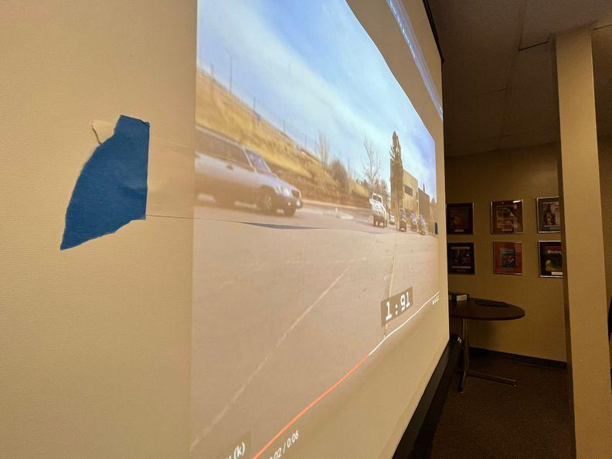 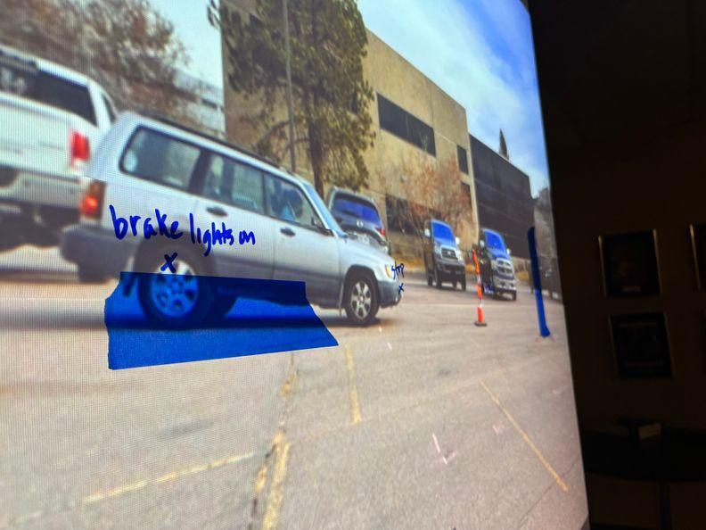  For the first video (not distracted), mark the important positions that can help us analyze the way it moves. Also mark the obstacle on the line. (If you are using a monitor, you can tape the strip of receipt paper carefully to the edges of the monitor, and make sure the brightness is up so that you can see the video through the paper.)  ADDITIONAL GUIDANCE Eventually the position-line that you are creating will end up vertical on your wall or whiteboard, as the y-axis of a position vs. time graph. Keep this in mind as you choose what size to make your receipt paper. You may decide to make the window with the video a little smaller on the screen to ensure that the position-line the class creates will fit on the whiteboard vertically later. If your position-line is too long, you can use a wall to create your graph later, but you will need to use sticky notes or chart paper for graphing.  Elicit students' ideas about what positions are “important.” Use probing questions to help them see the brake lights of the car go on, for example “Are there any changes to what we see when the car’s brakes go on?” Ask them what clues we can use to consistently determine the moment the car stops, for example, the rotating of the front tire. Be sure to mark the following positions on the receipt paper:  - Position 0: The car appears  - Position 1: The obstacle appears  - Position 2: The brake lights go on  - Position 3: The car comes to a complete stop✱  Once you have identified the important positions, as in the image above in blue, say, Let’s label and connect each of these positions so that we can visualize the distance between them. What should we call each point? Label the positions as students suggest them, and then ask students how we might abbreviate each one to keep track of them. Students may suggest using X₁ X₂ etc. If you are short on time, briefly explain the convention of subscripting the letter X as a way to keep track of different positions, saying, Let’s label the first position with a little 1, and the second position with a little 2, and so on, so that we can tell them apart. Then label each change in position as ΔX and ask students what to call these time intervals. Explain that scientists and engineers use Δ when measuring change, and that we call that symbol delta. Students will add this symbol to their personal glossaries in Lesson 5.  Introduce reaction distance and braking distance and add to our personal glossaries. Point to the interval between the appearance of the obstacle, and the brake lights, and say, What happens to the car during this interval? Look for students to say that the driver sees the obstacle, or reacts. Say, This is the interval where the driver reacts. So let’s call it the reaction distance. Have students record this idea in their personal glossaries. Do the same thing for the braking distance, which is the distance between when the driver begins to brake (or the brake lights go on in the video), and the car comes to a stop.  Record the distances to each point from the origin. Measure the distance from the position when the car first appeared (labeled X₀ in the examples) using a meter stick. The distance will most likely be great enough that you do not need to use decimal places beyond the cm measurement. If students want to use fractions of a centimeter, ask them to consider the error introduced by measurement.  ADDITIONAL GUIDANCE The conventions we use to describe kinematics are not always intuitive, and require the development of a new literacy for students. Consequently we should think of the use of these conventions much as we think of the introduction of new vocabulary. As with vocabulary, it is best to motivate a need for a new convention before providing the convention itself, so that it is earned. In the case of subscripts, for example, consider spending a moment asking students what we could do to differentiate between the different positions quickly. If students suggest using numbers or letters (i.e. 1, 2, 3; A, B, C), use the suggested class representations. When we start to keep track of times in addition to positions, students will quickly see the need to add something to indicate whether we are referencing a position or a time. At this point, you can tell them that scientists use X and t to reference time and position, and subscript these letters with numbers.  Use a manipulative to re-enact the video along the position-line. With students, briefly use the toy car to move in slow motion along the position-line from position to position, recreating the video clip. In order to help students draw additional conceptual connections between the representation and the real-life phenomenon, at each position that the toy car passes, ask, What happens when we get to this position? Do not worry about the timings yet.  Elicit ideas about how to calculate distances. Present slide D. Allow students to share their ideas about how we can use scale to determine the distance. Look for ideas about wanting to know the real length of something in the video. | ✱ ATTENDING TO EQUITY  Universal Design for Learning: This lesson calls for the use of multiple colors in graphical representations. Create a key to track what colors, symbols, or letter or number codes represent different parts of the system. While color coding is a useful way to quickly reference the parts of the model, letter or number coding helps ensure accessibility for any student who may be color blind. If color coding is used, consider a color palette that uses orange, blue, black, or dark brown, as these colors are more universally distinguishable.

3 · ADD DISTANCES TO POSITION LINE FOR CLIP #1 | 10 min
MATERIALS: Creating Position Lines, meter stick, chart markers (at least three colors)
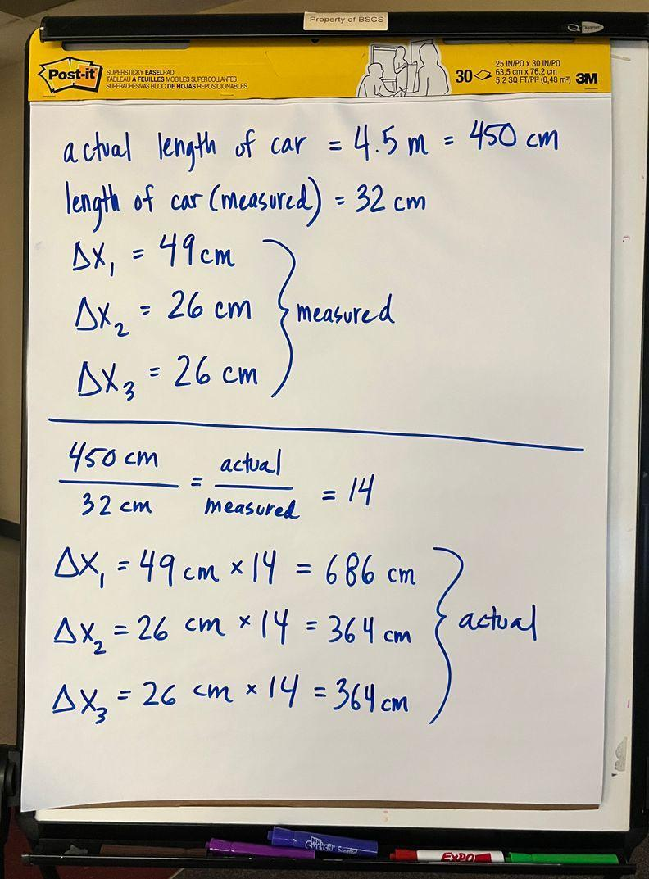  Calculate ΔX and add to the position-line. Say, I looked up the length of this kind of car. It is 4.5 meters long.  Present slide E. Pass out Creating Position Lines. Remind students that the car in the clip is 4.5 meters long. Ask the class for ideas about how to use what we know about the length of the car to find the actual distances in the clip. Look for ideas about finding the ratio of the actual car to the measured distance.✱  Follow the directions on the slide (and in the handout) as a class:  - Find the length of the car in the video clip at the scale that you watched it in the classroom. Record it on your handout.  - Find the length of the position intervals that you identified (the length between the important positions) at the same scale. Record them on your handout.  - Find the ratio of the actual length of the car to the length you measured. Set this ratio equal to the ratio of the actual distance of each of the position intervals to the measured length of that interval. Solve to get the actual length of each interval.  - Label the distances you calculated on the position line. | ✱ SUPPORTING STUDENTS IN ENGAGING IN USING MATHEMATICS AND COMPUTATIONAL THINKING  This is an opportunity to help students make connections between the models they have been developing in algebra, and the work they are doing in science class. To support this, ask, You know how in Algebra you solve equations? We may know some of the variables but we may not know others. If we know some measurements in this interaction, maybe we can solve for what we don't know. Have any of you done something like this before? How did you find out the measurement or number you didn't know? Then ask, OK, what is it we need to find out? That is our unknown. Are there any measurements here in the video or in the real-life situation that was captured that we know that can be used to figure out the actual distance?

4 · ANALYZE THE DISTRACTED DRIVER (CLIP #2) | 15 min
MATERIALS: toy car, one roll receipt paper
Make a prediction about a distracted driver. Present slide F. Use the prompt below to engage students in making a prediction.

Suggested prompt | Sample student response
Will the distances we calculated (reaction and braking) change if a person is distracted? How? | Yes, the reaction distance would be longer, maybe twice as long. The braking distance would be the same, or shorter.

As students describe it, use a toy car to illustrate by driving it along the position-line you created, acting out students’ predictions. Revoice and record the students’ prediction(s) in words near the front of the room, for example: “The reaction distance will be longer, but the braking distance will be the same. The car will take a longer distance to stop altogether.”

Compare predictions to the distracted driver. Present slide G. Label the first position-line as “non-distracted” and then move it above or below the path of the car to make room for another piece of receipt paper. Label this position-line “distracted.”

Watch the distracted driver video again and create a second position line on the new piece of receipt paper. Move through the same steps with the distracted driver video to create something that looks like the images below. If you have time, you can ask students to calculate the intervals again, using the handout. But in order to make time for creating position vs. time graphs, we recommend that you do these calculations quickly as a class.

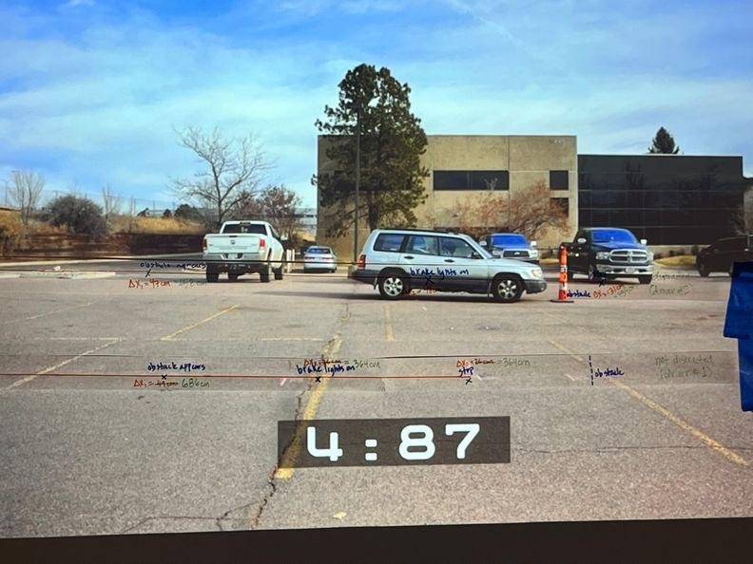 | 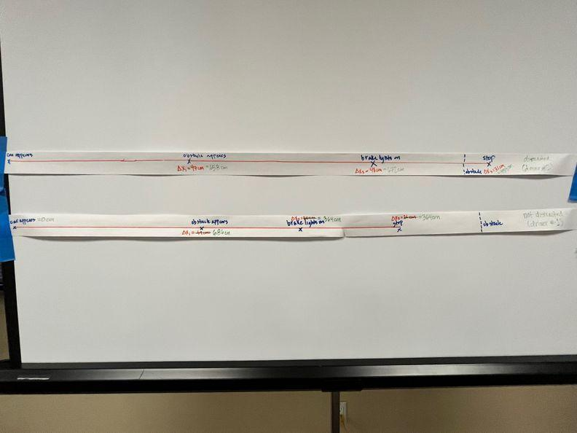

Ask students to explain why the lines are different. You can annotate the position-line as students describe their thinking, or underline students’ predictions at the front of the room to emphasize that they were supported by the data.

Present slide H. Give students a minute of individual think-time about the prompt on the slide before eliciting ideas from the class: How did our predictions match the data? How were they different from the data? Accept all student ideas.

ALTERNATE ACTIVITY | If you have an additional day, consider giving students the opportunity to do the analysis of the distracted driver on their own. Each student (or student pair) will need a computer, a thin-point dry-erase marker, and a transparency sheet. Students should use tape to attach the transparency sheet to the monitor, and then mark the positions of the car using the dry-erase marker, labeling each one. They can then measure the distance in between the marks they made, and go through the calculations on their own to determine the scale on their screens so that they can convert into meters. Average the results of the class to create a consensus position-time at the front of the room.

5 · NAVIGATE AND ASSIGN HOME LEARNING | 2 min
MATERIALS: Distracted Driving Research
Motivate analysis of timing. Use the toy car to “drive” along the line again, recreating the distracted scenario. Then present slide I and ask, Why are these distances so different for the distracted driver? What was different about how the distracted driver was driving that could explain why these distances were different? Look for students to identify speed or timing in order to motivate an analysis of the time intervals in the video. Use the prompt/response example below as a guide.

Suggested prompt | Sample student response
What was different about how the distracted driver was driving that could explain why these distances were different? | They might be going faster.
How will this affect braking? | They might have to brake harder.
What does it mean to brake harder? | They might go the same distance, but have to do it in less time.
Does everyone agree that the timing may be different in between these positions as well as the distance?

It is not important whether or not students say the braking time is the same or longer. Make sure to listen for students to think through the fact that the reaction time will be longer, and the braking time will either be shorter, or the same.

Present slide J and say, I heard ideas about speeding, and how fast you stop. These are all related to the time it takes for the car to move and slow down and stop. But we have only been able to analyze this video based on distance. Let’s take a closer look at the timing of the videos next time.

Assign Home Learning. Let’s read about the time it takes to stop tonight, and then see if that can give us some insight into the timing of the videos we watched today. Give each student a copy of Distracted Driving Research. The text has a Lexile score of 1010-1200 and is 843 words long.

End of day 1

6 · NAVIGATE: REACTION TIME | 3 min
MATERIALS: None
Focus on the relationship between distraction and reaction time. Present slide K, and pose the prompts below to get students thinking about the difference between measuring distance traveled, and time passed.
Suggested prompt | Sample student response
What insights did looking at the distances that the car traveled give us into the system? | It helped us calculate how far the car moved.
How did the article frame it? Distance or time? | Time.
How much does being distracted impact the time it takes for a car to stop? | According to the reading it could double the time it takes.
Doubling is a lot! Do you think this is true? | (accept all ideas)

Articulate our motivation to analyze timing. Present slide L. Say, How could looking at the timing of each scenario help us understand how distracted driving could change the outcome of a possible collision? Have students turn and talk, and share out some ideas.

Add reaction time to our personal glossaries. Say, In the article you read that the time it takes for you to hit your brakes when you see something you might hit is called your reaction time. Let’s keep track of that phrase, because it means something very specific.

Take a moment to add reaction time to students’ personal glossaries. Students may define it in terms of driving (the time it takes for a driver to hit the brakes when they see an obstacle), or in terms of biology (the time it takes for an animal or plant to react after sensing a stimulus).

ALTERNATE ACTIVITY | Optional (requires an additional 15 minutes): Ask, How could we test to see if being distracted impacts our reaction time? Have students use https://www.justpark.com/creative/reaction-time-test/ to test their reaction times normally, and then when another student is distracting them, and notice that being distracted does make a difference. You can also give students something to unwrap, like a fast food cheeseburger, or a book wrapped in paper to simulate someone who is trying to eat and drive.  Another way to measure reaction time is the ruler drop test. One person holds a ruler by the end and the other person watches it and gets ready to catch it. This person tries to catch the ruler as quickly as possible after it is dropped. Where on the ruler the second person catches it an accurate measure of time because the acceleration due to gravity is constant on the surface of the Earth.

Say, There is always a delay in how fast you can react to something. Researchers say that being distracted doubles that time and our test bears that out….but we are talking about moments here. We are talking about half a second versus a quarter of a second. How much of a difference do these small changes in reaction time make in avoiding a crash?

7 · CREATE A TIMELINE OF CLIP #1 TOGETHER | 5 min
MATERIALS: one roll receipt paper
Create a timeline of the non-distracted driver. Present slide M. Use a new strip of paper to reconstruct a timeline for the non-distracted video. This does not need to be exactly the same length as the paper you used for the position-line, but should be on the same scale, as you will eventually combine these lines to create the axes of a graph. You can do this on the projector screen again, or on a sturdier surface like a white board or wall. Start by creating tick-marks using the relevant units of time. Ask students what units we should use for our tick marks. The class should decide on seconds as the relevant unit. The videos are 6 seconds and 7 seconds long, respectively, so your line will probably go to about 7 seconds. In the example timeline below we made each tick mark one decimeter apart.

Use the time code from the video to figure out the times associated with each position that you identified. Then determine the lengths of each time interval and add this information to the timelines, as in the image below. Be sure to label this timeline as “not distracted.”

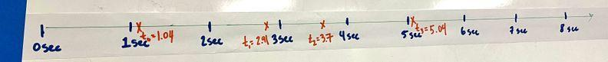

8 · CREATE A POSITION V. TIME GRAPH | 20 min
MATERIALS: paper with three hole punch, graph paper with three hole punch, one roll receipt paper
Motivate comparing our variables. Present slide N. Say, We have two different ways to look at this clip, through time, and through position. What could we do to visualize what’s happening here in both dimensions, time AND position, and look for a relationship between them? Give students time to consider this question with a partner, and then elicit ideas publicly. If students need more scaffolding here, use the prompts below to help them consider what they have done in the past, and if necessary, guide them to think about graphing specifically.  Suggested prompt Sample student response  What have we done in the past to compare two different variables, and look for relationships between them? Graphing on two axes.  How can an x-y graph help us understand the relationship between two variables? The graph tells us what y is given a value x.  Consider the relevant variables. Present slide O. Say, The variable on the y-axis is usually the one that changes depending on the x-axis...or the dependent variable. The variable that determines the dependent variable is called the independent variable. Give students 30 seconds to discuss with a partner or think independently before eliciting ideas about the following prompt.  Suggested prompt Sample student response  Which of these variables determines the other? We can’t change time, and time determines distance.  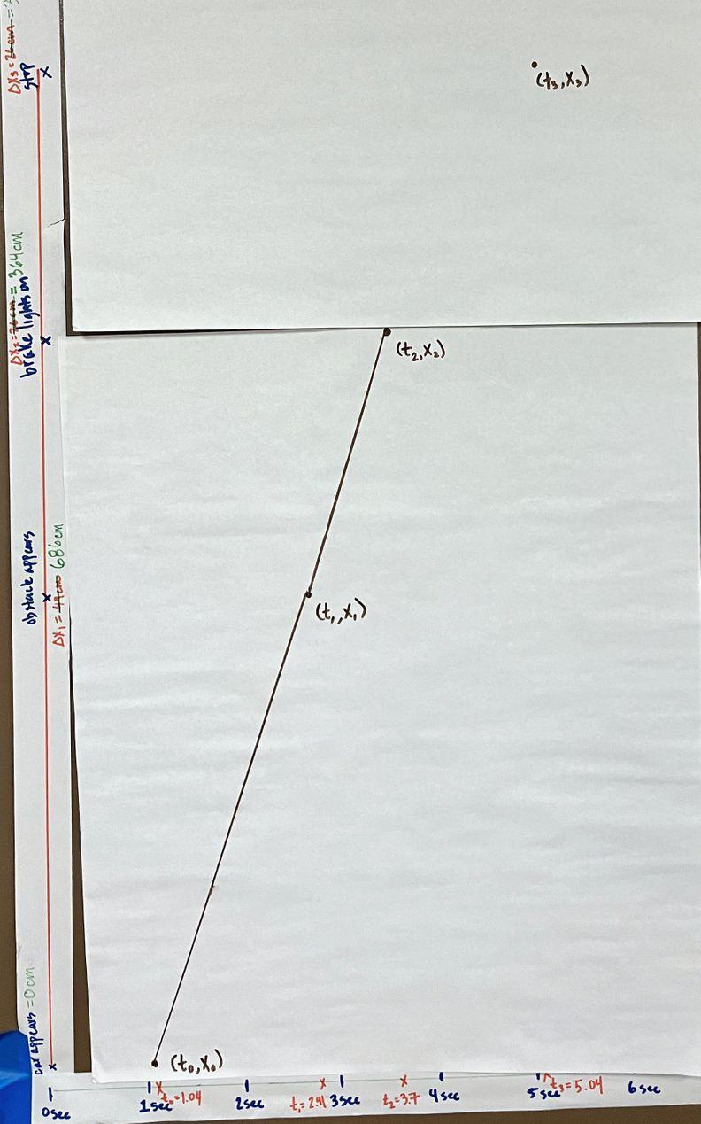  Say, So let’s leave time on the x-axis. Let’s take position, and put it on the y-axis. That way we can visualize how position changes over time.  Create the y-axis by repositioning the position-line. Take the strip of paper with position and move it up and sideways to be the y-axis for the timeline like in the image at right, meeting the origins of each line at the bottom left corner. You may want to move through the next several steps without projecting slides to focus attention on the graphing. If so, you can skip slide P, otherwise use slide P to articulate the task for the class.  Determine the lines between points. Ask, How do we represent the moment the car appeared, in both time and position on this graph? Help students see that we can graph this point, and use a meterstick to plot each point: (t₀, x₀); (t₁, x₁); (t₂, x₂); (t₃, x₃).  Say, What is the car doing between time 0 and time 1? Look for students to suggest that it is moving from position 0 to position 1. Add this line. Repeat for the other two intervals.  Copy the graph into student notebooks. Have students copy the plot the class makes onto a new piece of paper for their notebooks.  Interpret the graph. Ask students to turn and talk for a minute about the prompt on slide Q: What information do these lines tell us about the motion of the car at that position/time? Then bring the class together  Consider what the first line tells us. Ask, What does this first line tell us about how the car is moving? Accept all ideas, but highlight any ideas students have about speed if they come up.  Suggested prompt Sample student response  How far did the car have to move to get from x₀ to x₁? About 6.9 meters (or 690 cm)  And looking at the x-axis, how long did it take the car to move from here to here? About 1.9 seconds  ADDITIONAL GUIDANCE Encourage students to round to a single decimal point throughout these calculations. If your students have learned about significant figures in math or in previous science classes, you can scaffold this move by reminding them that measured numbers always have a limited number of significant figures. For multiplication, the LEAST number of significant figures in any number of the problem determines the number of significant figures in the answer. Because we used 4.5 meters (the given length of the car) to determine all of our distances, and that number has two significant figures, we need to stick to two significant figures.  Calculate the speed of the car before braking. Write 6.9 meters/1.9 seconds on the whiteboard.  Say, In math terms we call this the slope of the line, or how much the y axis changes every time to x axis changes. Label the fraction as “slope of the line over interval Δx₁.” Then say, Let’s take a closer look at what this slope is telling us.  Suggested prompt Sample student response  6.9 meters per 1.9 seconds, that’s meters per second. Where else have we heard distance over time? Meters per second is a speed.  So what do we need to do to determine how fast the car is going on average in this period? Divide the numerator by the denominator.  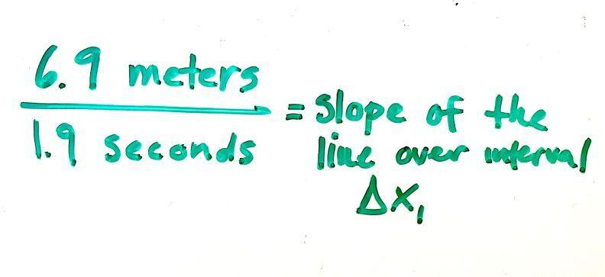  Go through the calculations as a class. You should find that the car was moving at about 3.6 meters per second. (Optionally type this into Google to convert, or do the calculations with students to figure out what this means in MPH. 1 meter/second is 2.23694 MPH.) Then repeat these calculations for the second time interval. You should find that the car was moving at about 4.6 meters per second after the obstacle appears but before braking.  ADDITIONAL GUIDANCE The car is going approximately 4 meters/second in the clip before braking, but students should get slightly different values for the average speeds of intervals 1 and 2. If students are puzzled by this, explain that in real life a car’s speed is always changing, and that these represent averages.    Articulate the relationship between slope and speed in a quick assessment moment. Present slide R. Pose the first prompt to the class.  Suggested prompt Sample student response  Based on the work we just did, what can the slope of a line in a position versus time graph tell us about how the car is moving? It tells us the speed.  Then ask students to respond to prompts A-C on a sheet of paper. Collect these papers before the end of class to check the class’ interpretation of these kinds of graphs.  - What does a steeper slope mean about the motion of the object?  - What would it mean about the motion of the object if the slope were zero (a flat line)?  - What would it mean if the slope was negative?  ASSESSMENT OPPORTUNITY What look/listen for in the moment: - (prompt A) When the slope is steeper, the object is moving faster. (CCC: 7.2) - (prompt B) When the slope is zero the object isn’t moving. (CCC: 7.2) - (prompt C) When the slope is negative the object is moving backward. (CCC: 7.2) What to do: Do not use this to assign a score to students, but rather use it to decide whether the class needs more practice interpreting position versus time graphs. Consider reaching out to a math colleague to find out what students are expected to know in their math classes about change over time. If only a couple of students are struggling, consider meeting with these students one on one to analyze the graphs and the video in more detail before the next class. Students will use this change over time thinking as the lesson goes on to interpret the video, and describe factors that affect risk. Building toward 2.A.1 Analyze video of two drivers encountering a sudden obstacle by graphing change in distance over time, in order to describe and predict how certain factors can affect the risk of a potential vehicle collision. (SEP: 4.1; CCC: 7.2; DCI: ETS1.A)  Add a horizontal line after time 3. Present slide S. Use the prompts below to motivate a straight horizontal line after time 3.  Suggested prompt Sample student response  What is the car doing after time 3? It is stopped.  So what is its speed? Zero meters/second.  As the speed gets slower and slower, how does the slope change? It gets less steep.  So what do we think this line is going to look like then, if the car is not moving at all? How will it’s position change over time? It will look like a straight line. The position doesn’t change over time. (Add this line to the graph.)  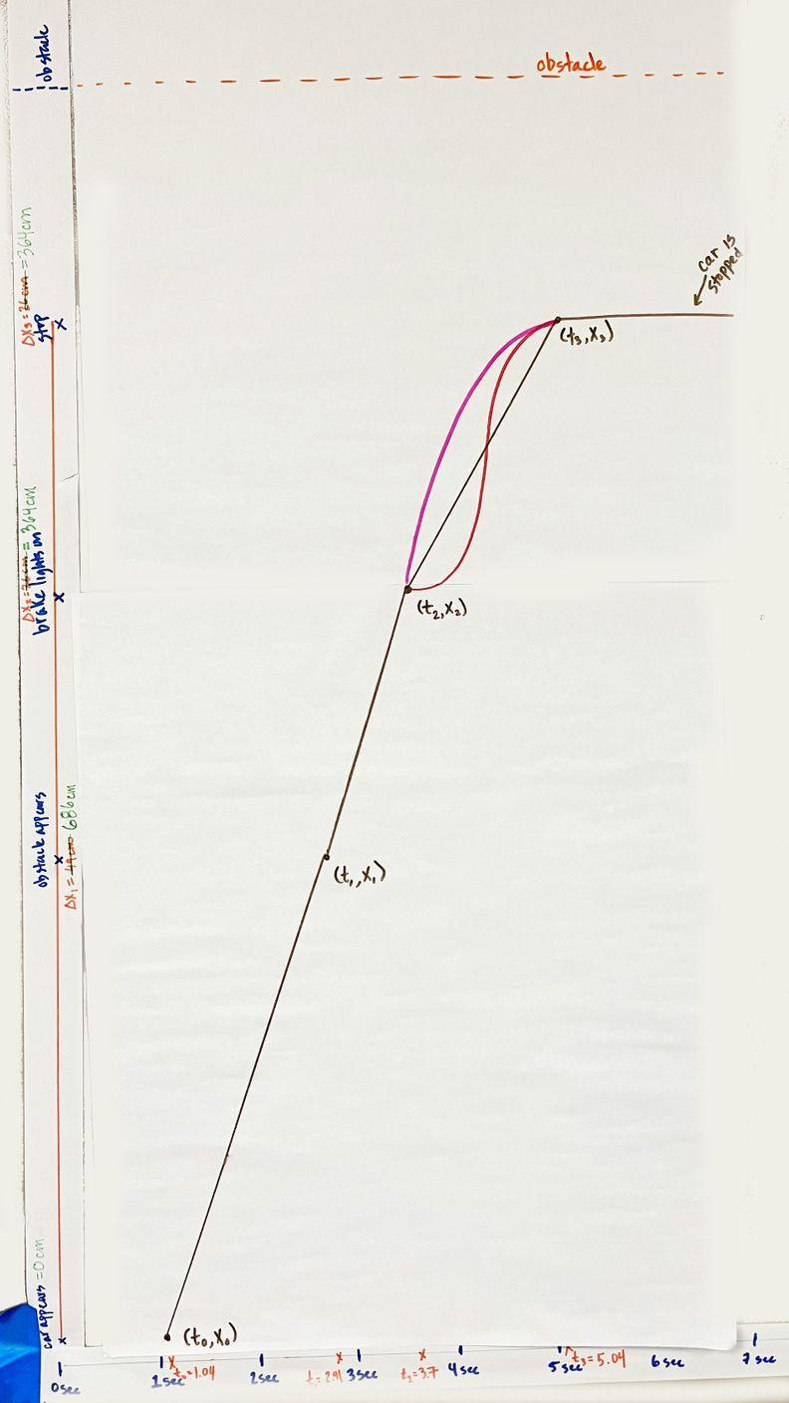  Consider the line representing braking. Say, A straight line between two points indicates that the speed is constant over that time. Is that true of the car? Is the speed constant between these two points for example?  Point to t₃. Do the calculation here quickly (3.6m/1.3s)= 2.8 m/sec. Consider asking students to do their own calculations on their white boards.  Ask, But is the car really going that speed the whole time? Students may need some individual think time here. Look for them to recognize that the car is starting at about 4 m/s and then slowing down to zero. Use the toy car to help students clarify their thinking here. You can ask students to take the car and demonstrate how it is moving between these two points.  Say, So near this dot here, this third dot, the line should be almost flat, because it doesn’t go straight from 4 to 0, it changes over time. Extend the flat line from beyond the third point to before the third point just a tiny bit. Then ask, What do you think the line looks like between the second two dots?  Give students a chance to make predictions and argue. Ask students to come up and draw what they think the line will look like. Use a different color to indicate that this is a prediction. If you have competing ideas among students, give each student a different color so that you can differentiate between the predictions.  Add the obstacle. Present slide T. Say, In this video, the car avoided a collision. Can we add the obstacle to our position line to show where the obstacle is? Ask a student to come up and add to the graph where the obstacle was.  Record in our notebooks. Give students a chance to briefly record the lines we added to the graph they began for their notebooks. | ✱ SUPPORTING STUDENTS IN DEVELOPING AND USING STABILITY AND CHANGE  In this unit, students will progressively develop a deeper understanding around the following CCC element: Change and rates of change can be quantified and modeled over very short or very long periods of time. In this lesson, students “invent” position versus time graphs in order to answer their questions, motivating a quantification of a rate of change (speed) for the first time in the unit. The time over which students think about rates of change here is relatively long (on the order of several seconds). Later in the unit, students will begin to model changes in a similar way, but over very short periods of time, under a second, in order to better understand the forces involved in the collision itself.  ✱ SUPPORTING STUDENTS IN ENGAGING IN ANALYZING AND INTERPRETING DATA  If your students need more support interpreting the graph, consider using the Identify and Interpret (I²) sensemaking strategy. This strategy helps students break down an information-rich graph into smaller pieces to interpret. In the I² strategy, students first identify changes, trends, or differences. They draw an arrow to each observation and then write a “What I see” (WIS) comment. These comments should simply be what the student observes, such as a positive slope on a graph or increasing numbers in a data table. After students have made all their observations and written their WIS comments, they should interpret the meaning of their observations by writing a “What it means” (WIM) comment for each. Once students have mastered WIS and WIM comments, ask them to create a caption for the graph, figure, or table. A caption is a summary of all the information and helps show students’ understanding.

9 · GRAPH THE DISTRACTED SCENARIO IN PAIRS | 15 min
MATERIALS: graph paper with three hole punch

Graph the collision if the driver was distracted in pairs. Present slide U. Say, Let’s figure out what this line would look like if the driver was distracted. Ask students to work with a partner to go through the same steps for the distracted driver. They can create their graphs using the same axes as the non-distracted driver, as long as they use a different color. Alternatively, you can have students create a separate graph on a new piece of paper and compare across them. Make sure that the position and time lines that the class made for the distracted driver are clearly visible for students.

ALTERNATE ACTIVITY | If there is time, come together as a whole group and graph the distracted driver on the same axes that the class made for the non-distracted driver. You can move the position-line that the class created to the left of the vertical position-line for the non-distracted driver. Use another color and/or pattern, and create a key to distinguish between the two lines.

Debrief the graphing. With 5 minutes left of class, give students a chance to share what they noticed. Present slide V and ask, What differences did you notice that could explain why being distracted increases the likelihood of a vehicle collision?

ASSESSMENT OPPORTUNITY | What look/listen for in the moment:  Look for students to correctly analyze the distracted driver video by graphing position over time for clip #2 as in the example above. Then in the debrief, look for students to explain that:  - The graphs show that the distracted driver moved further between the appearance of the obstacle, and the brake lights (CCC: 7.2)  - That suggests that being distracted will increase the time it takes to react to something (reaction time) (DCI: ETS1.A)  - Longer reaction time means that the car will travel further before stopping (stopping distance), and be more likely to hit the obstacle. (SEP: 4.1)  What to do:  - As students graph, move around the classroom and support students who are struggling. Point to the steps they moved through to graph the first series. Use probing questions to get them to articulate the steps we moved through as a class and why: What did we do when we did this together? What were we trying to figure out when we did that?  - To get ideas flowing during the debrief, you can hold up two graphs and point to differences that we can observe easily and ask students what those differences mean. Ask students to point to evidence from their graphs to support their reasoning as they share ideas.  Building toward 2.A.2 Analyze video of two drivers encountering a sudden obstacle by graphing change in distance over time, in order to describe and predict how certain factors can affect the risk of a potential vehicle collision. (SEP: 4.1; CCC: 7.2; DCI: ETS1.A)

10 · NAVIGATE WITH AN EXIT TICKET | 2 min
MATERIALS: paper for exit ticket
Exit ticket. Say, It seems like a shorter reaction time is key for preventing accidents. Present slide W and ask students to respond to the prompt on the slide as an exit ticket: What else could increase a driver’s reaction time, other than if the driver is distracted?

If there is time, ask students to share out. Otherwise, collect the exit tickets and read through them so that you can summarize students’ ideas at the start of the next lesson.

